**Amazon Sales Data Analysis using Python**

* Source file: Amazon sales CSV file
* Size 128976 rows * 21 columns
* Removed Null rows and Null columns
* Post to cleaning 37514 rows, 19 columns
* Converted datatypes of few columns as required.

KPI and solutions:

1. What is the most ordered size?

As per the below graph, the most ordered size is 'M' with count of 6806

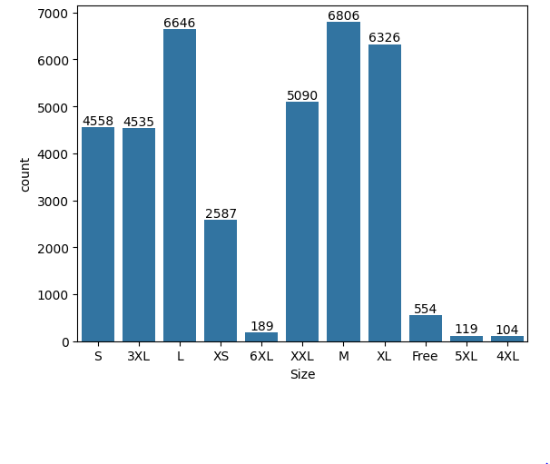

1. What are the quantities of orders in each size and which is the Max?

The below graph shows the quantity ordered based on the size and the size "Medium" has the Maximum quantity as '5905'

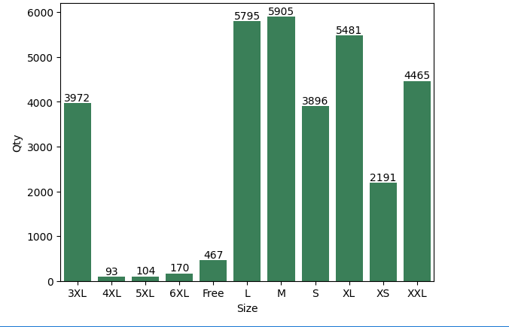

1. Which is the most ordered Category?

As per the below histogram the most ordered Category are T-shirts.

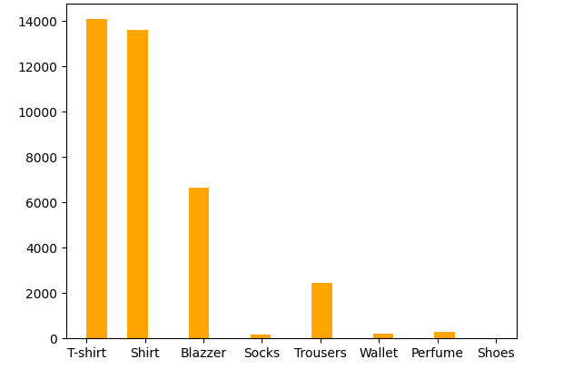

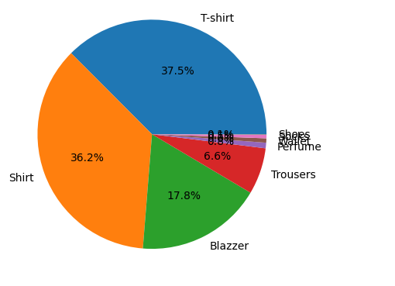

1. Who are maximum buyers and what is their percent?

The retail buyers are maximum.

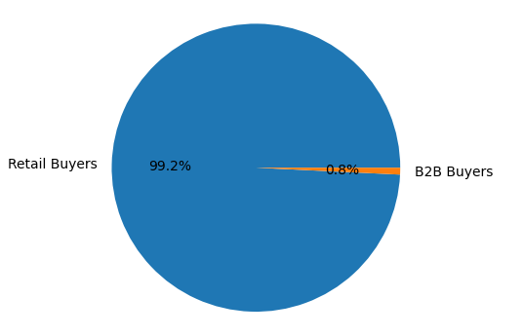

1. Which state in India have placed most orders?

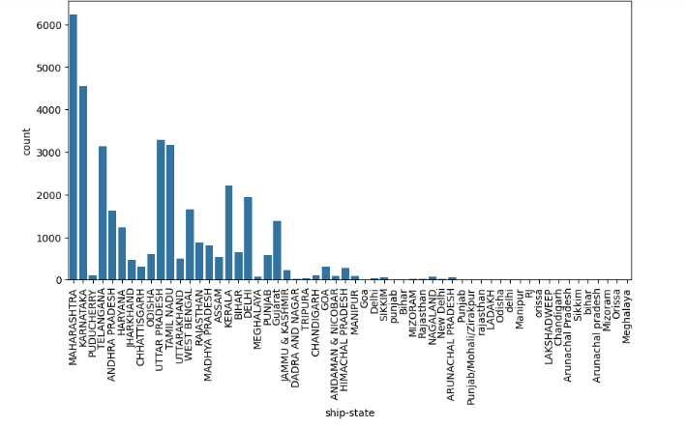

1. Showing top 10 selling states.

